**Press statement**

[CBPP_logo_color](http://www.policymattersohio.org)

For immediate release

February 23, 2016

Contact: Hannah Halbert, 614.221.4505

**Start from Scratch:**

Senate is rightly concerned about legislation overhauling Ohio’s unemployment compensation system; Stakeholder input is needed, not an insider deal

The Ohio Senate majority is rightly concerned about House Bill 394, the severely flawed bill to overhaul Ohio’s unemployment compensation system. *The Columbus Dispatch* reported that an “informal group” of Republican representatives and senators would meet to discuss the bill. Policy Matters Ohio has [testified](http://www.policymattersohio.org/unemployment-jan2016) in opposition to this extreme legislation, which would weaken our unemployment system.

It is encouraging that the House has chosen to press, “pause” on HB 394. However, if the group of legislators discussing the bill want to take a balanced approach to fixing Ohio’s insolvent unemployment compensation system, they should scrap the bill and initiate real stakeholder engagement. Like many others, Policy Matters Ohio has said the General Assembly should start over because HB 394 places the entire load for improving the system on unemployed workers – and then doesn’t meet its own solvency target because it would give away hundreds of millions of dollars a year in employer tax cuts. That isn’t a balanced approach, and it mistakenly acts as if Ohio is overly generous with unemployment benefits. In fact, it’s our tax system that’s out of whack:

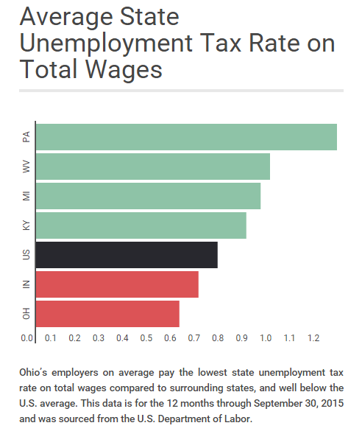

The joint legislative group is far more likely to produce a measure Ohioans can support if legislators don’t start out including extreme provisions like reducing benefits to as little as 12 weeks, cutting benefits to those receiving Social Security retirement and adding new eligibility requirements and waiting weeks. As described in a recent Policy Matters Ohio guest [blog](http://www.policymattersohio.org/blogpost-uc-feb2016), Ohio’s unemployment compensation system long has provided benefits to a smaller share of the state’s jobless than other systems across the country do.

This group should listen to the voices of all those affected, including unemployed workers and employee representatives. A solution must draw support from Ohioans regardless of their political affiliation.

###

*Policy Matters Ohio is a nonprofit, nonpartisan state policy research institute with offices in Cleveland and Columbus.*